**copper stamping sink**

**Product Introduction**：

Copper stamping sink is an assembly of a base and a stamped fin which are soldered ,brazed or epoxied together. Copper stamping sink has good thermal performance due to it allows high-density fins and fin aspect ratios . and it is also has design flexibility , expecially with integrating heat pipes or ducting for fans or blowers.

Customers can chose base soldering with fin solution , or add heat pipe in design for higher performance request, and fans, blowers can provide much more thermal conductivity in cooling system applications.

**Product Parameters:**

|  |  |
| --- | --- |
| Product Name | copper stamping sink |
| Material | copper |
| Surface treatment | Nickel Plated or Anti-oxidant |
| Process | Stamping,soldering,Brazing,epoxied |
| HeatPipes Quantity | 0-8 heat pipes, based on customer TDP required |
| Size： | Customized |
| Shape | Customized |
| Tolerance | ±0.1 or stricter |
| Application | Server cooling system ，computer CPU cooling Medical equipment, Telecom Engineering,etc |
| Sample LT | 10-20days after payment in advance |
| Quality Contral | 100% thermal test for HP assembly,  and 100% visual check before shipping |
| Quality Guarantee | 2 years |
| Brand Name | Sinda Thermal |
| Certification | Rohs,SGS,GB/T19001-2016,ISO9001:2015 |
| Place of Origin | DongGuan,Guangdong, China |
| Port | SHENZHEN,HONGKONG |

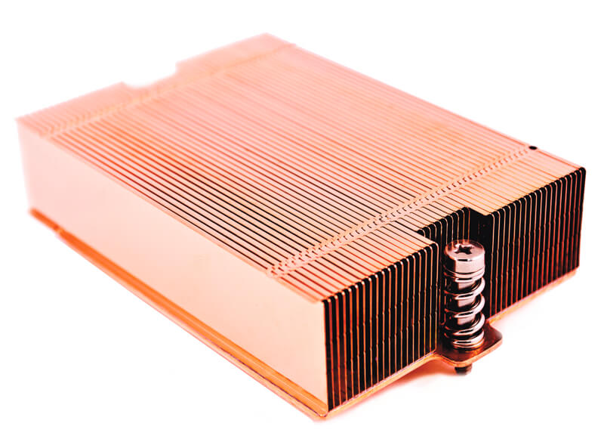Detailed Images:

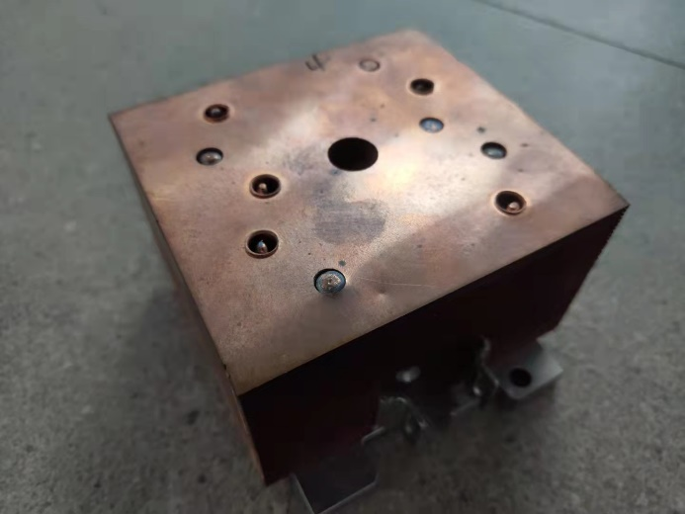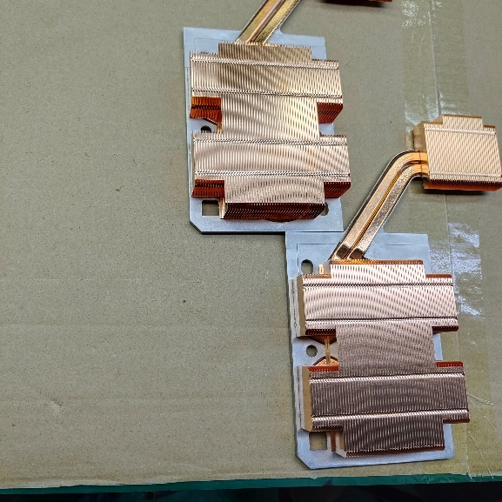

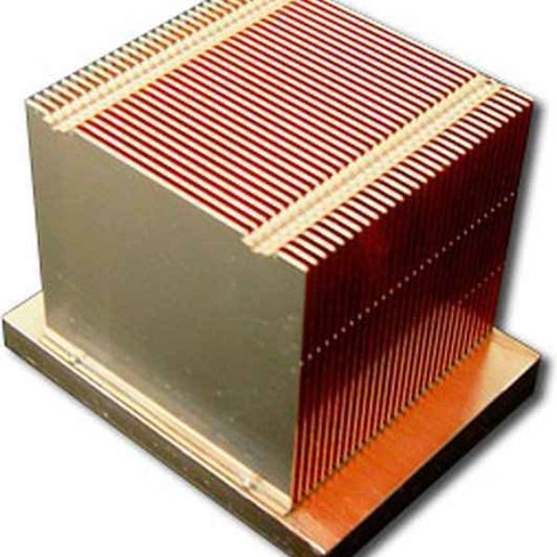

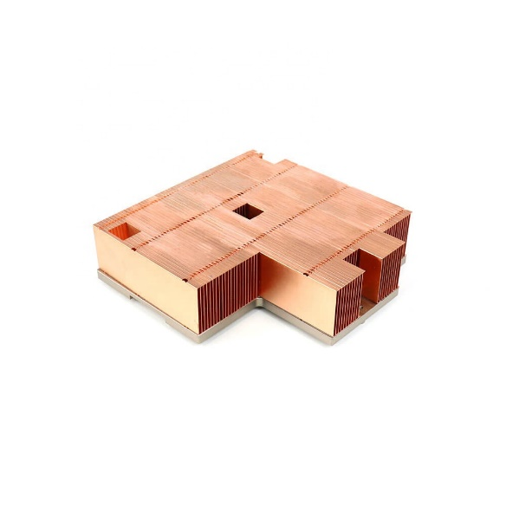

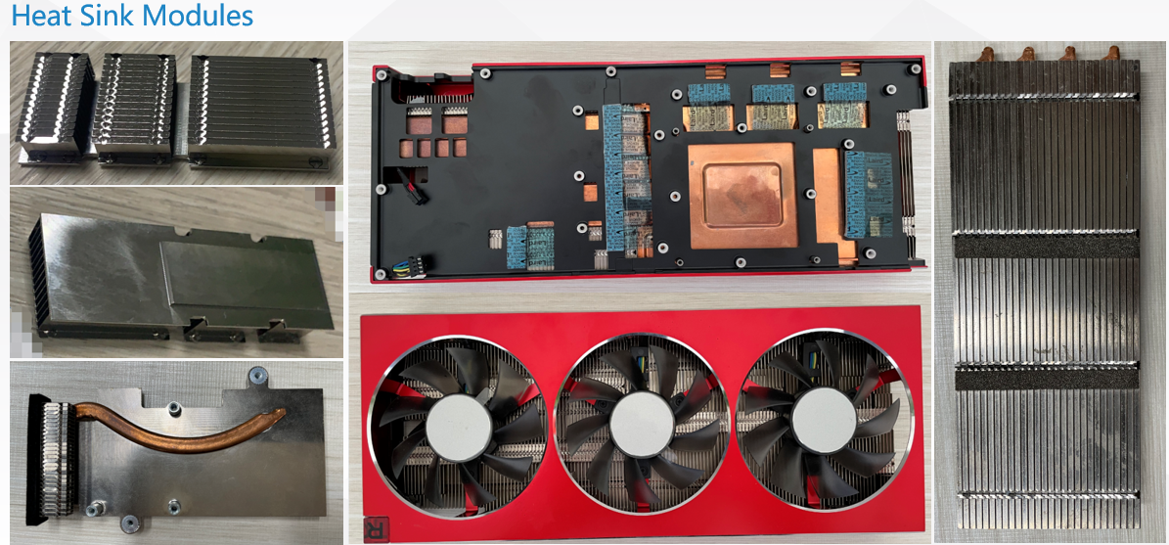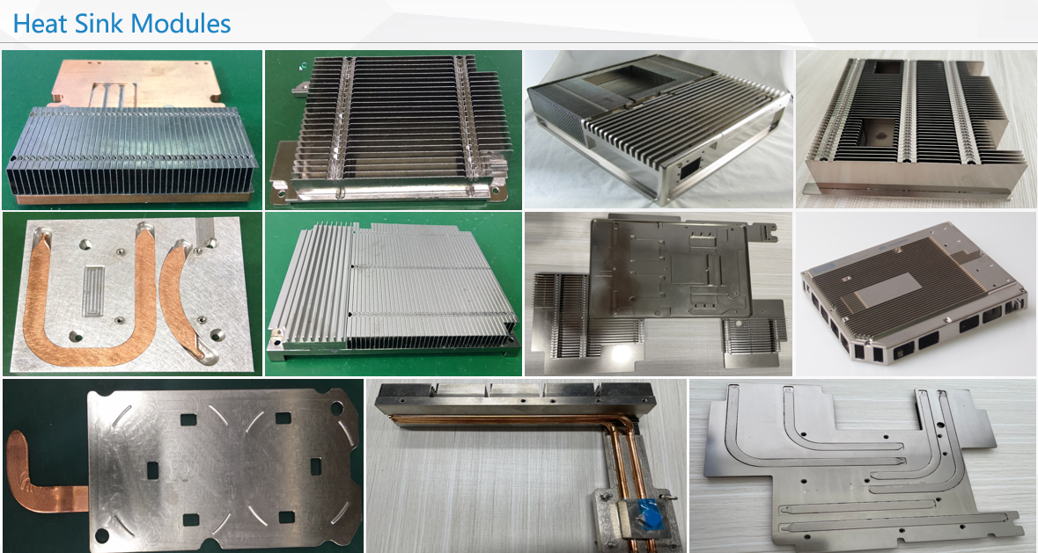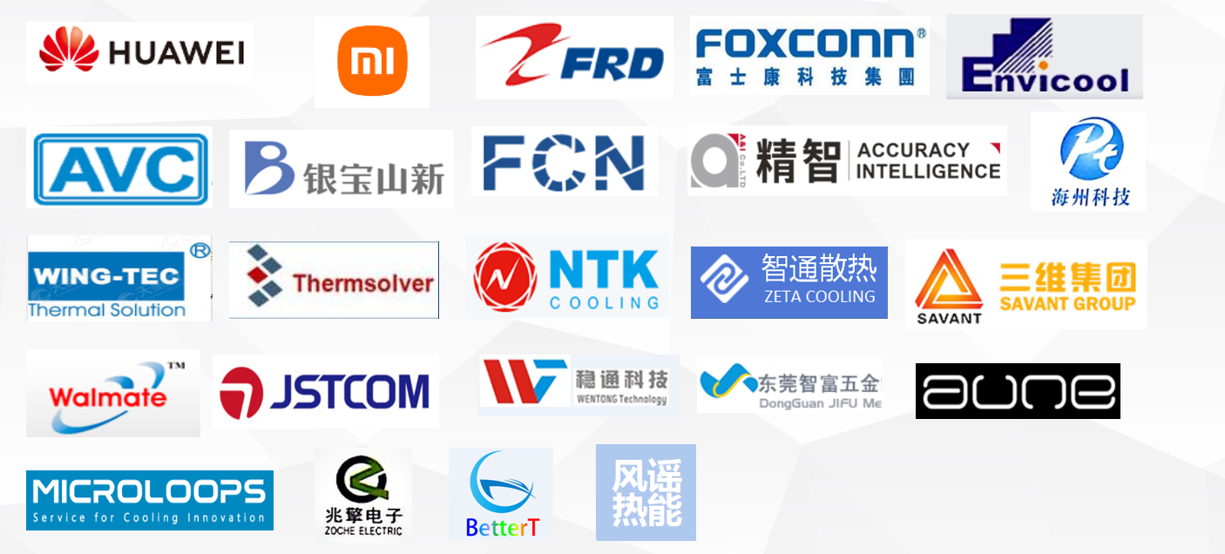**Our Customers & Products:**

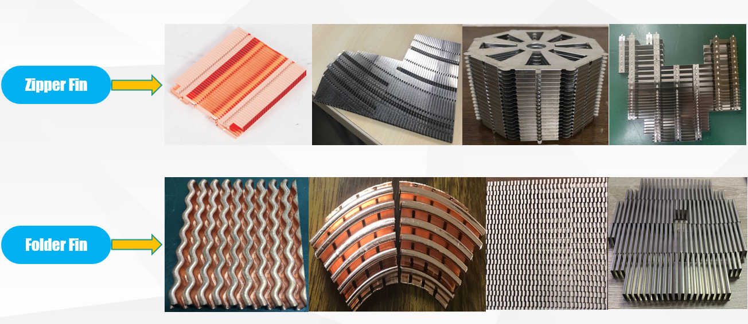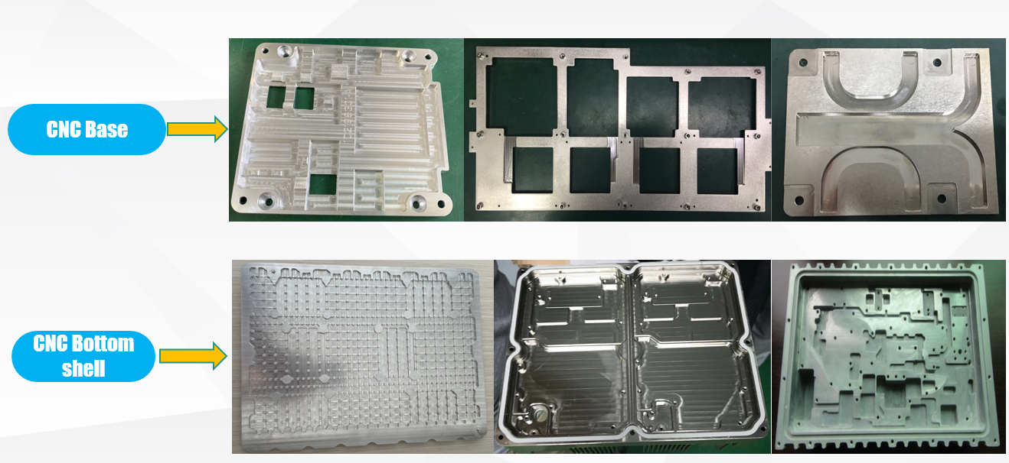

**FAQ:**

Q: How can I get the quotation?

A: Please send us your detailed information , 3D drawing and 2D drawing with notes will be great help , we will quote to you in 24 hours after information confirmed

Q: Is there any extra tooling cost for my product?

A: Usually, no tooling cost required for sample build; but for customized parts in mass production , tooling cost will be covered.

Q: What’s your shipping methods?

A: Customers can chose DHL, UPS, FedEx ,TNT ,EMS,etc as their prefer freight forwarder, normal freight term is FCA HK.

Q: What package do you use for shipment?

A: For heatsink modules, we usually use customized plastic tray and carton

as our mainly packages, customized service is also available.